**GURU NANAK COLLEGE(AUTONOMOUS),CHENNAI**

**PLACEMENT DETAILS FOR WEBSITE**

1. **MEGA JOB FAIR 2016 @ GURU NANAK COLLEGE**

A job fair by Estaviainfotech services was organized at Guru Nanak College, Chennai on 23rdjuly 2016.The Job fair was inaugurated by Dr.M.Selvaraj,Principal ,Guru Nanak College and Dr.Gunita Arun Chandok, College Director. Mr. S.K. Prabhu, HR Manager,Estaviainfotech, Ms.M.L.Mayalekshmi and Dr.Umadevi ,placement cell coordinators were present. Around 30+ reputed IT,Core and BPO sectors took part in the fair. TVS services,Hinduja Global Services,Reliance,IndusInd Bank,Eureka Forbes,Aegis and intele were some of the participating companies .Around 1500 candidates from various colleges participated in the fair.

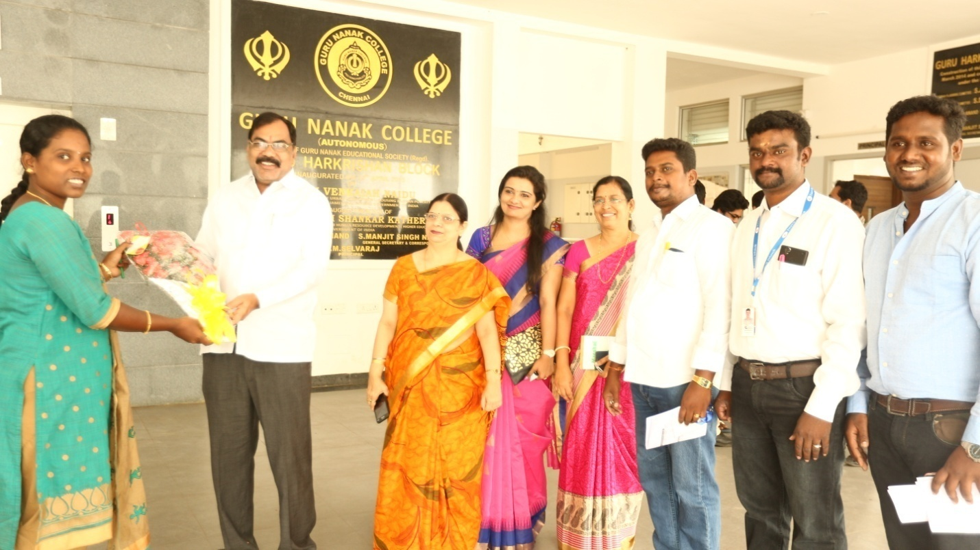

(II) BARCLAYS GTT TRAINING PROGRAMME

Barclays have initiated a training programme as a part of their CSR.A MOU was signed between Gurunanak College, Barclays and the training partner GTT to get better placements .After the successful completion of the training “A Graduation day of Barclays Life Skills Training Programmes was organized on **6th October 2016**.Mr.Gautham Shiva ,Senior Director,Mr.Shrikant Sinha,CEO,NASSCOM foundation,Mr.Niljothi Banerjee ,GTT were the guest of Honour.Over. 300 students graduated and received certificates,on the successful completion of the training Programme.

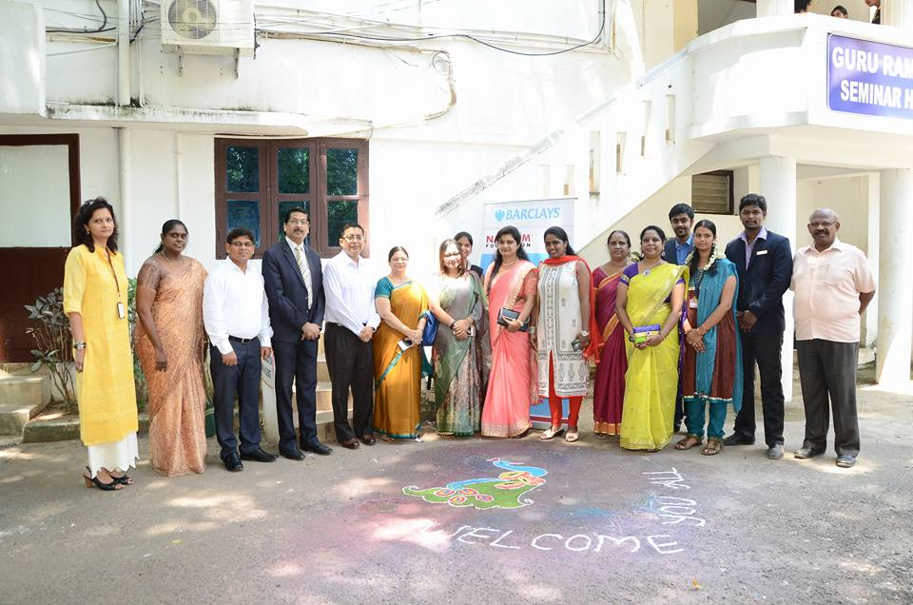

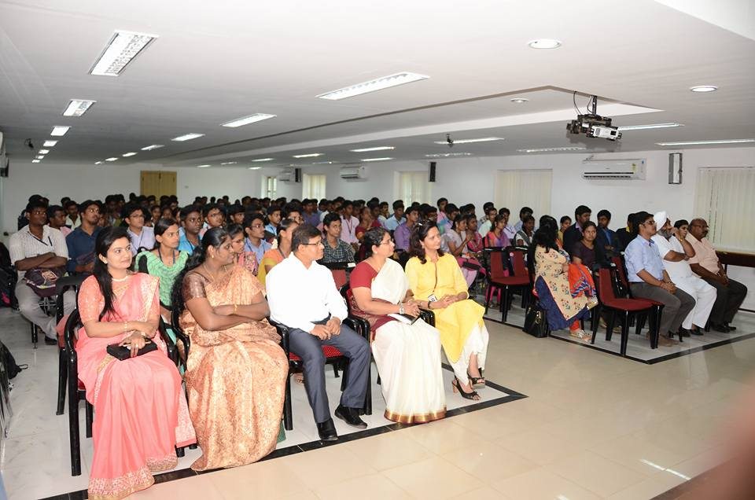

1. ***SACCA Institute of Freight & Tourism gave a seminar on the career opportunities in the field of Shipping and Logistics.***

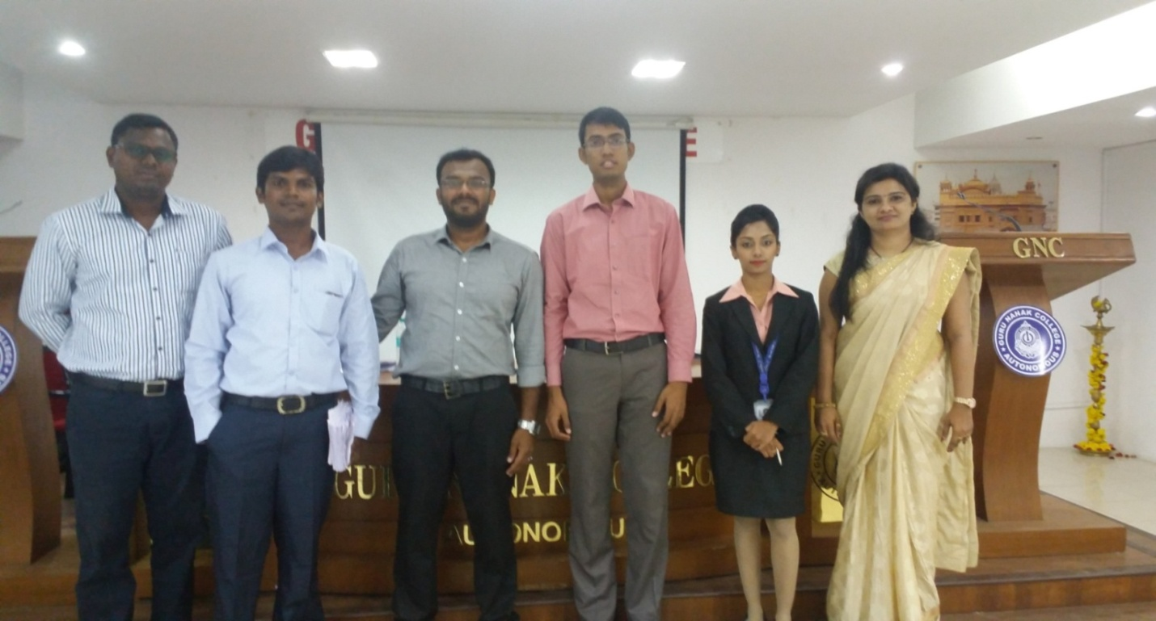

1. *ITM Business School conducted a National Level Aptitude test For Women Students and four of   
   our students got Scholarships for higher studies   
   with a fee waver upto* ***Rs.7.5 lakhs***

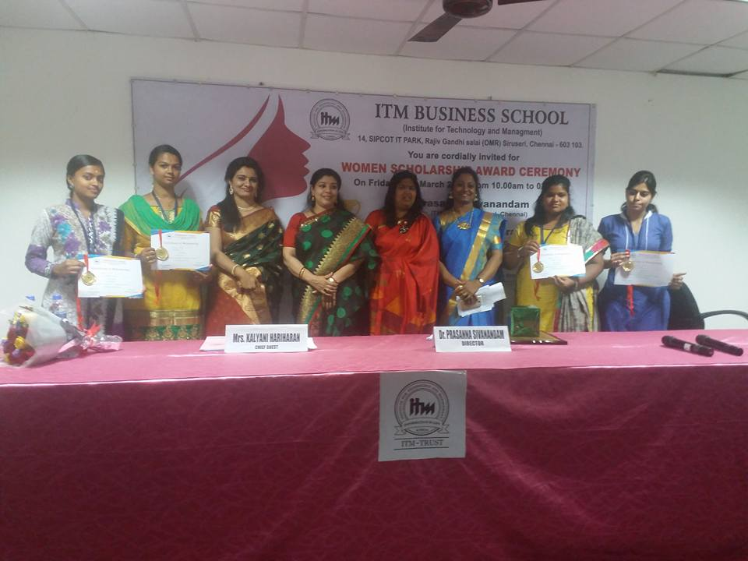

1. The GOOGLE team were invited to conduct   
   a seminar on “The new innovations by GOOGLE” on Crowd sourcing and Community Development. on **16.03.2017.**

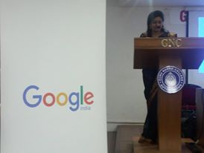

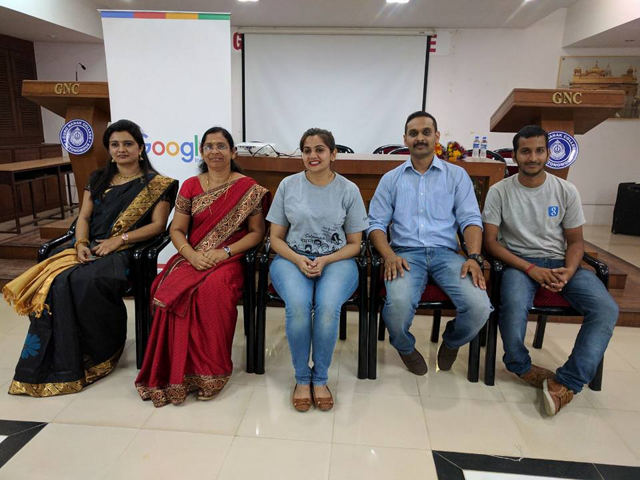

Placement Activities of 2016-2017

|  |  |  |
| --- | --- | --- |
| Sl:No | Name of the Company | No:of students selected |
| 1 | **HCL Technologies** | 2 |
| 2 | **Job Fair(2013-2016)** | 15 |
| 3 | **Ernst & Young Global** | 8 |
| 4 | **N Trust** | 10 |
| 5 | **Capegemini** | 21 |
| 6 | L& T | 4 |
| 7 | **Sutherlands Global Services** | 15 |
| 8 | **Pro Edge** | 58 |
| 9 | **Cognizent Technologies** | 6 |
| 10 | **TCS** | 31 |
| 11 | **CAMS** | 94 |
| 12 | **Accenture** | 16 |
| 13 | **Nation star** | 39 |
| 14 | **Agility** | 10 |
| 15 | **AllsecTechnologies** | 25 |
| 16 | **Just Dial** | 21 |
| 17 | **ICICI Bank** | 04 |
| 18 | **Reliance** | 08 |
|  |  |  |

**PLACEMENT Activities of 2017-18**

On 18th of September , Ernst & Young visited Guru Nanak College for the pre placement programme. The orientation session lasted for 3 hours which was conducted byMr. Joel , manager of GDS and Morris , HR -Head. The orientation consisted of specifications on resume making and an elaborate incite of GDS (Global Development Service) for which the company was hiring the students.

The orientation also consisted of question and answer session which was positively answered by the managers.

The following photos are the gist of the event:

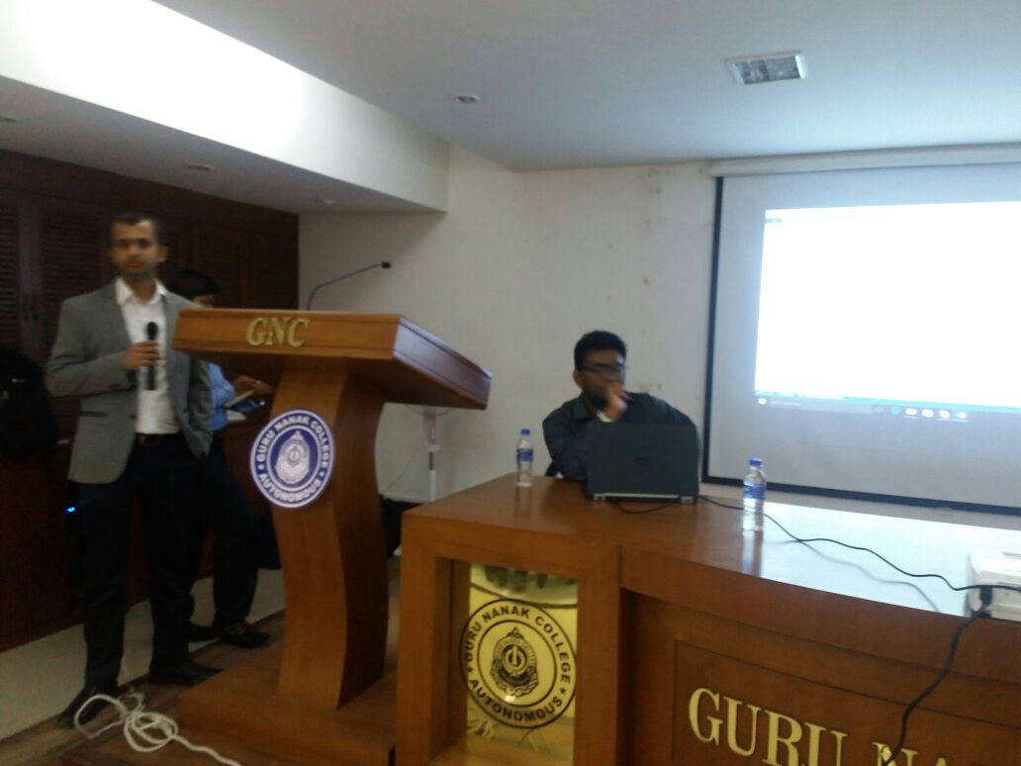 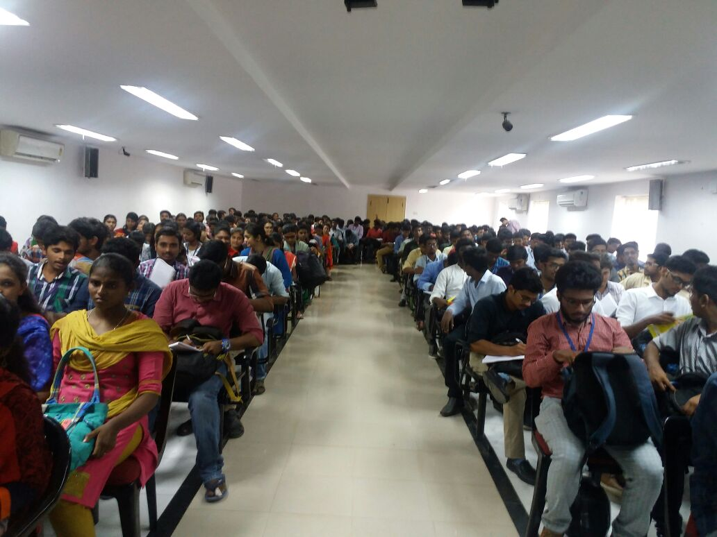

Joel (left) and Morris (Right) 300 plus students gathering

On 27th of September , Ernst & Young Global visited Guru Nanak College for the On Campus Drive.. During the Drive General Manager of EY GDS,Mr Amit addressed the students , HR -Head. Mr. Joel , manager of GDS and Morris , HR –Head were also present.Three students from shift II got selected in the drive.Adhiya Shankar Arumugham(B.Com –Honours),Saurabh Srinivasan(B.ComGeneral) and Sharun A(B.ComGeneral) are the selected students.

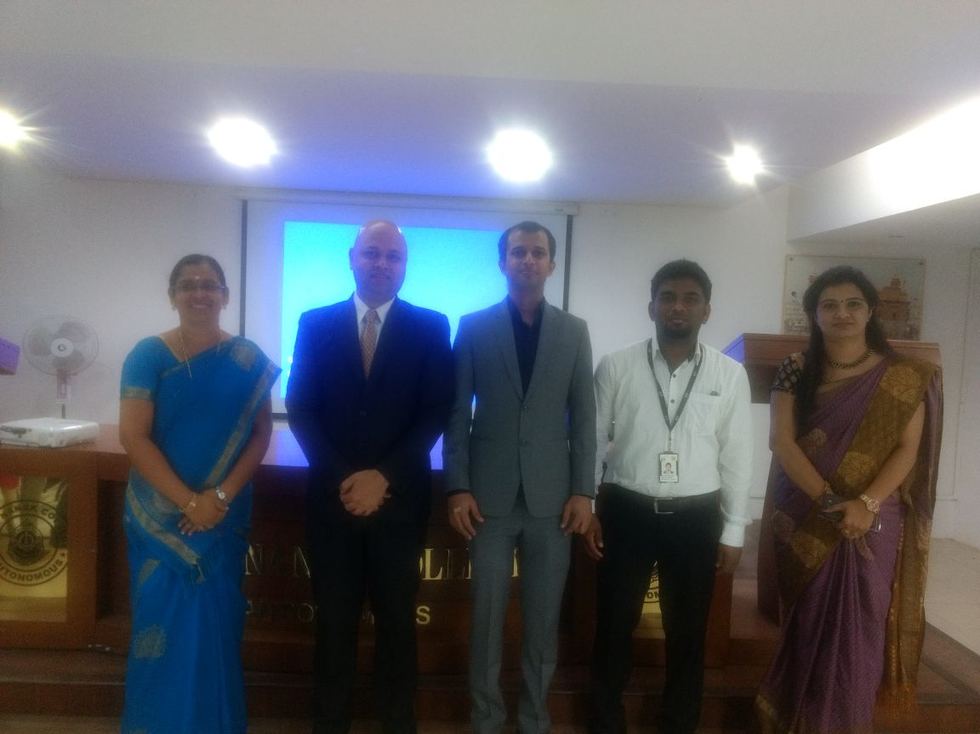

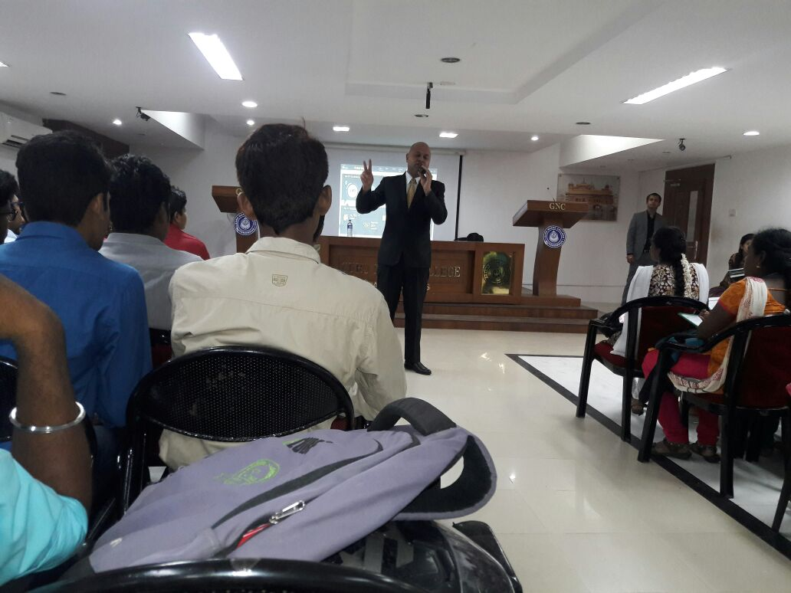

XSEED item

Idea turning into business for implementing a very large scale infrastructure (VLSI) project

Date : 21 sept 2017

On 21st of sept , XSEED item , a start up company and a renowned entrepreneur Dr. Ravi Dakshinamoorthy visisted our campus and address the student gathering on the new techniques and developmental projects for the development of the economic conditions of the country. The presentation was based on the manufacturing and start-ups.

The presentation consisted of very deep theoretical and practical approaches which needed high analytical skills.

Dr. Ravi Dakshinamoorthy is the founder and CEO of XSEED item.

On 27th October 2017,Deloitte conducted its Chennai regional Drive in our Campus.Mr.Mohan,Regional Manager South was participated in the addressing session

